Introduction

Project Overview
Our engagement centers on turning Ethan Hunt’s raw real-estate data into an executive-ready Tableau story that clarifies housing-market dynamics for strategic decision-making. A four-person specialist team—data engineer, visualization designer, domain analyst, and project lead—will cleanse and enrich multi-source datasets, then craft interactive dashboards highlighting price trends, inventory shifts, geographic hot spots, and time-to-sale patterns. The project follows a prototype-first approach: within 48 hours Ethan receives an initial dashboard to validate direction, ensuring rapid iterations and full alignment with stakeholder questions.
Beyond the core build, we embed sustainability and scalability. Reusable Tableau Prep flows automate future data refreshes, while template-driven dashboards allow quick expansion into new regions or data streams. Training sessions and a 30-day post-launch support window empower Ethan’s team to self-service minor tweaks and confidently present insights to executives. Altogether, the project transforms overwhelming datasets into clear, persuasive visual narratives —reducing analysis turnaround times, raising decision-maker confidence, and laying groundwork for ongoing analytic maturity.

Purpose
Transform messy, multi-source housing data into clear, interactive Tableau dashboards that reveal price trends, inventory shifts, and geographic hot spots.
- Empower Ethan to present confident, data-driven recommendations to executives, shortening analysis and decision cycles.
- Establish a repeatable data-prep and visualization framework so future updates and new regions can be onboarded with minimal effort.
- Elevate stakeholder understanding and trust in real-estate insights, ultimately guiding smarter investment and development strategies.

Ideation Phase

Problem Statement
Problem Statement | I am (Customer) | I’m trying to | But | Because | Which makes me feel
PS-1 | Ethan Hunt | Communicate insights. | The raw data is messy. | My reports influence  investment decisions. | Motivated
PS-2 | A real-estate market analyst. | Understand housing market trends. | The raw data is inconsistent. | Clients rely on me for insights. | Frustrated

Empathy Map Canvas
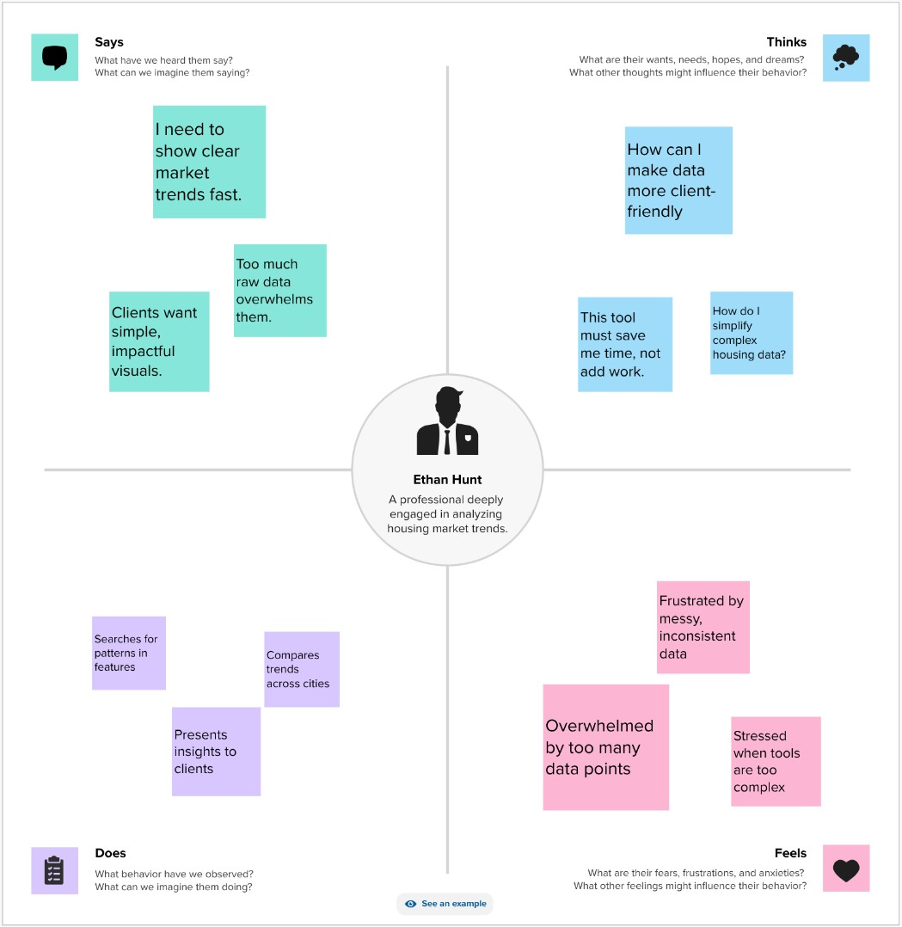

Brainstorming
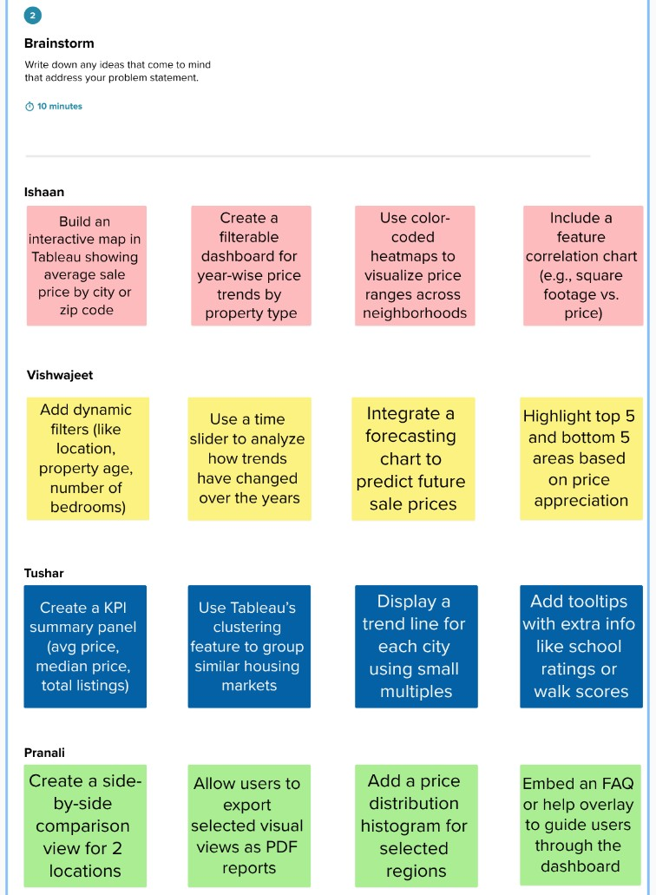

REQUIREMENT ANALYSIS

Customer Journey map
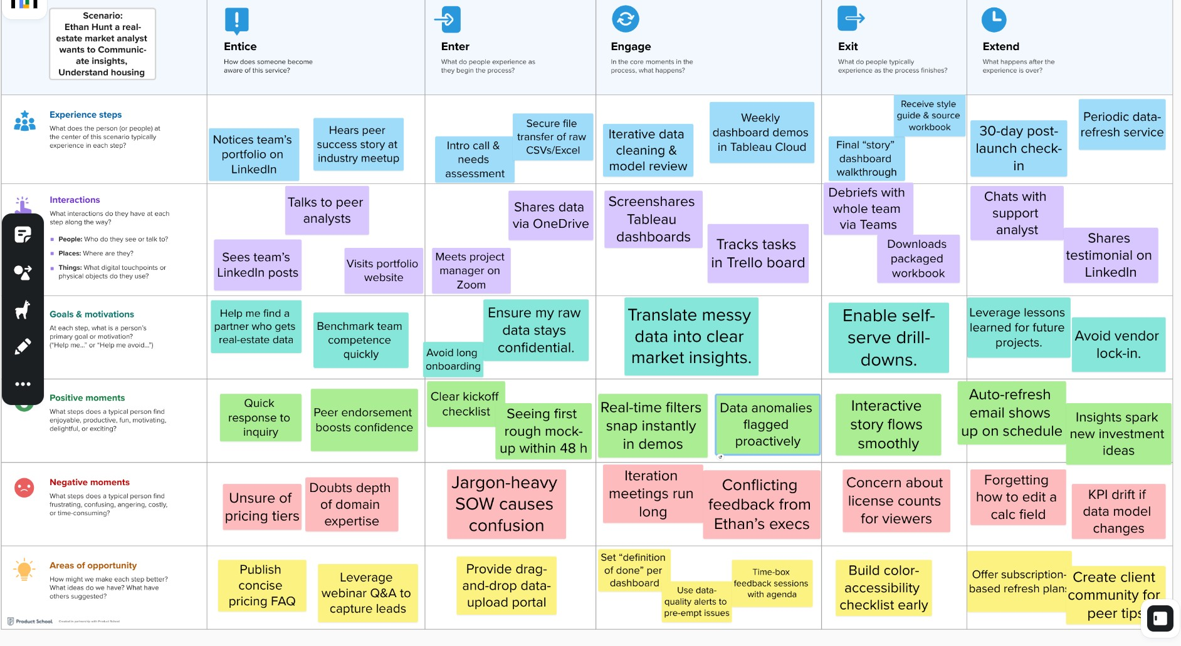

Solution Requirement
Functional Requirements:
Following are the functional requirements of the proposed solution.
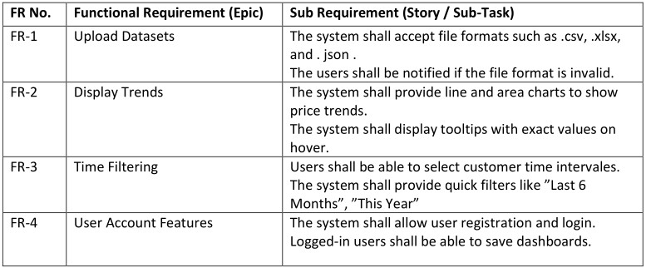
Non-functional Requirements:
Following are the non-functional requirements of the proposed solution.
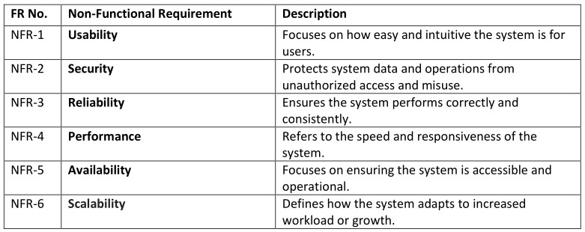

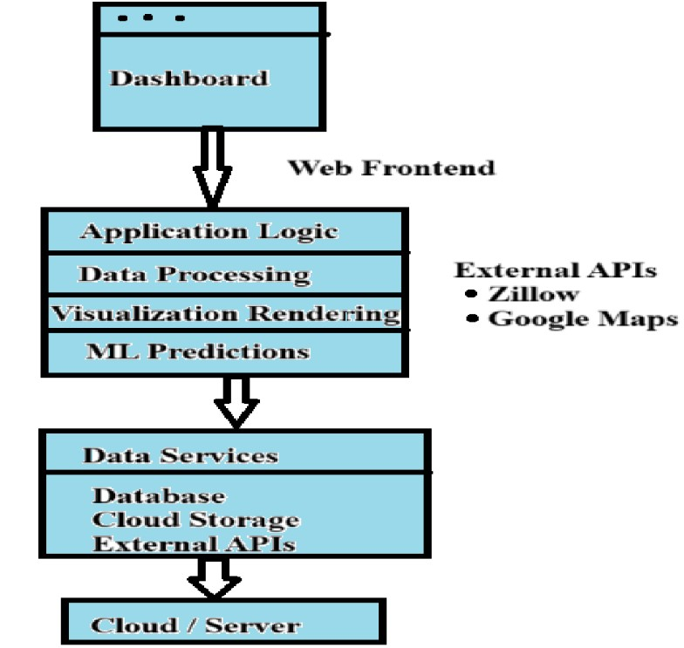
Data Flow Diagram
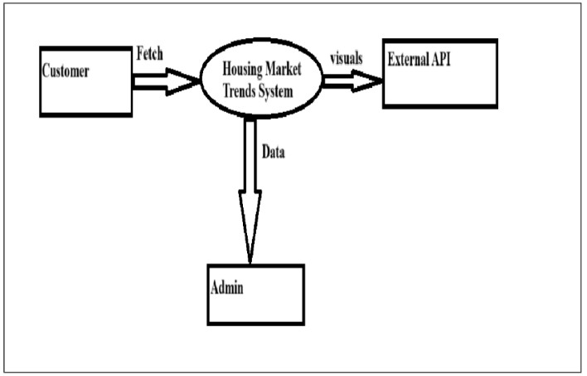
3.4 Technology Stack

PROJECT DESIGN

Problem Solution Fit
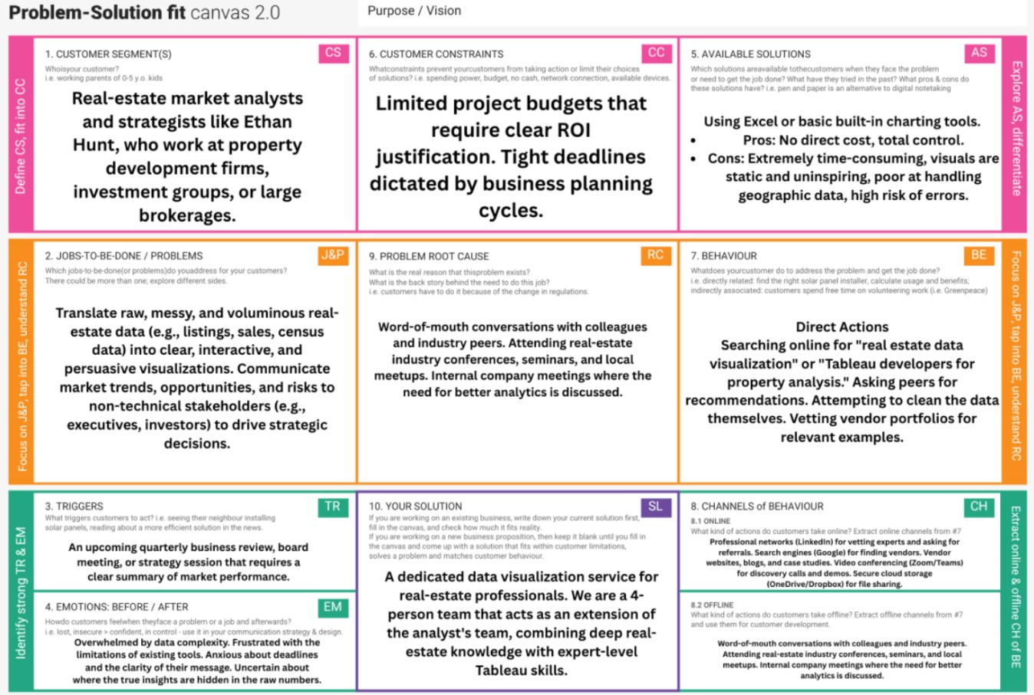

Proposed Solution
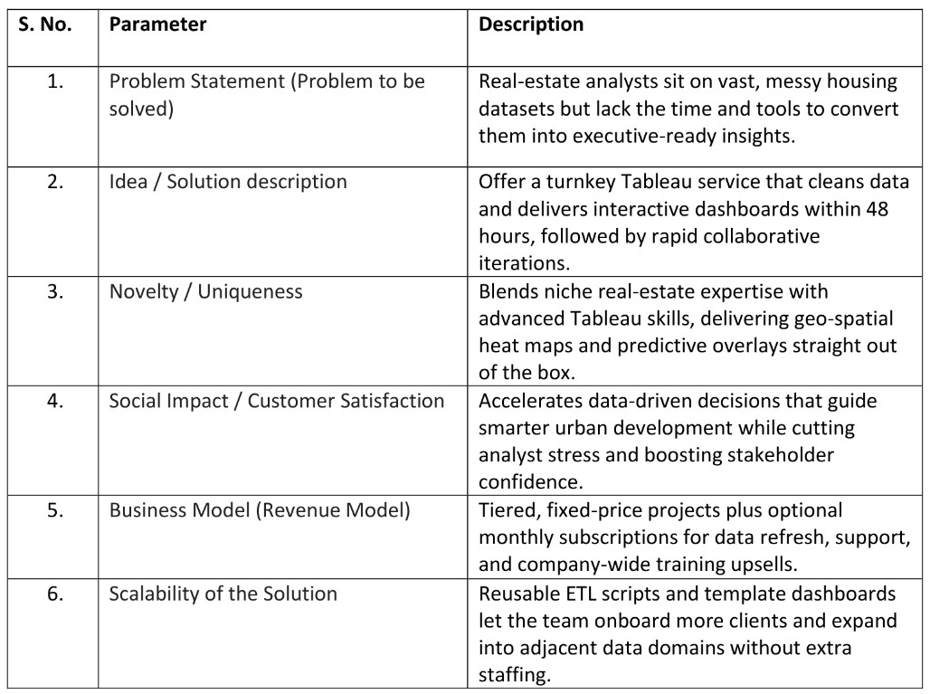

Solution Architecture

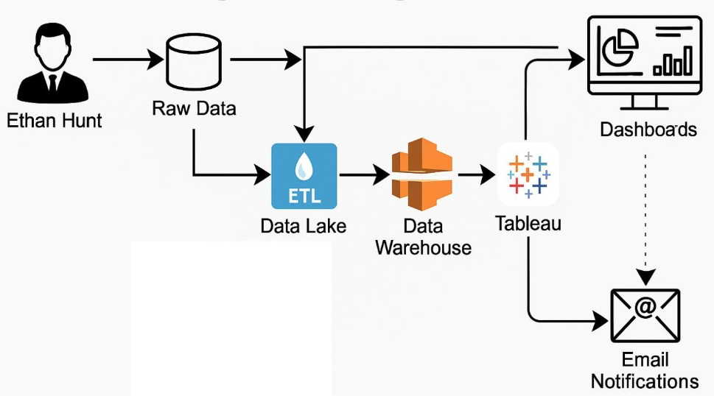

PROJECT PLANNING & SCHEDULING

Project Planning
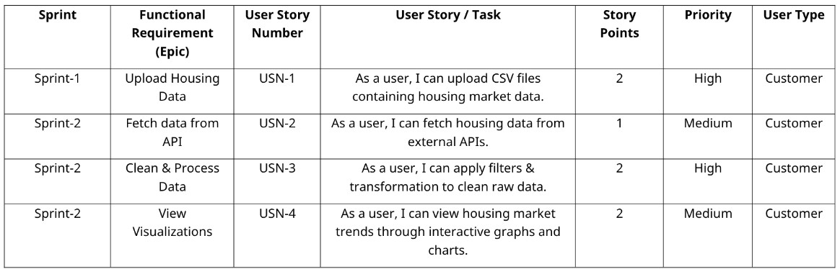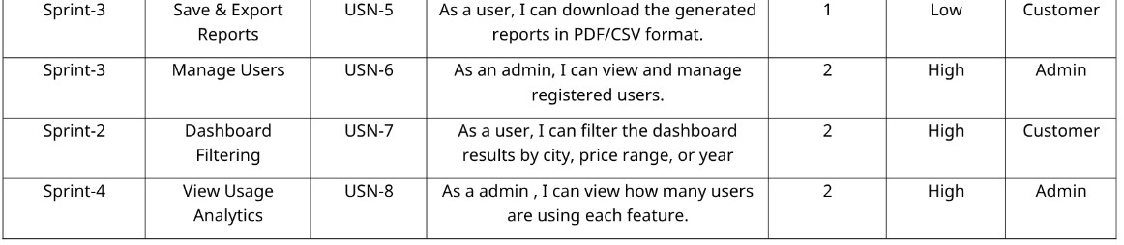

FUNCTIONAL AND PERFORMANCE TESTING

Performance Testing
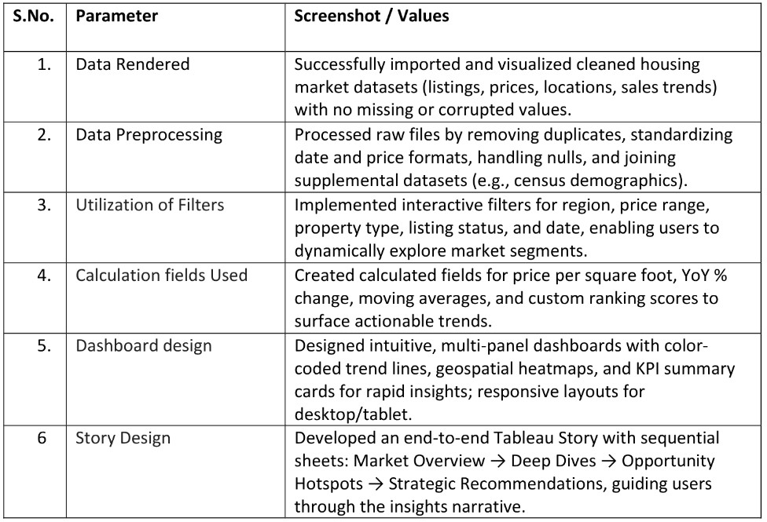

RESULTS

Output Screenshots
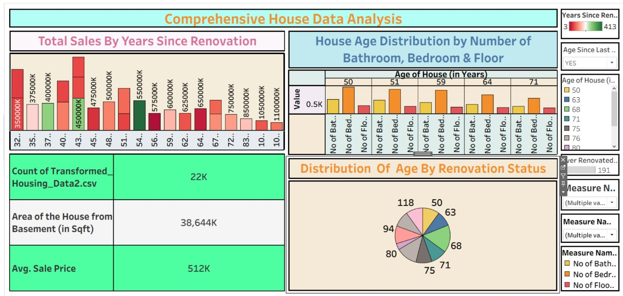

ADVANTAGES & DISADVANTAGES
Advantages
Rapid Insight Delivery
Our prototype-first workflow produces an initial Tableau dashboard within 48 h, letting Ethan validate direction early and keep the project tightly aligned with stakeholder needs. This shortens analysis cycles and builds executive confidence faster than traditional, sequential BI engagements.
Domain-Tailored Expertise
The four-person team combines real-estate knowledge with advanced Tableau and data-engineering skills, delivering geo-spatial heat maps, predictive overlays, and accessibility-ready color palettes that generic consultants rarely offer. Ethan gains visuals that speak his market’s nuances without needing to train an external vendor on the basics.
Disadvantages
Specialized Cost Structure
Premium, niche talent and rapid-turnaround service come at a higher price point than DIY approaches or commodity BI freelancers. For firms with tight budgets, the tiered fixed-fee plus optional subscription model may still feel prohibitive.
Vendor Dependency Risk
Although we provide training and reusable Prep flows, Ethan could remain reliant on our team for complex updates or new analytic modules. If internal capacity or Tableau proficiency doesn’t grow in parallel, long-term dependence may limit flexibility and increase total cost of ownership.

Conclusion
Our Tableau-driven solution converts Ethan’s raw housing data into a clear, interactive narrative that accelerates insight and boosts executive confidence. By coupling rapid prototypes with reusable Prep flows, we’ve built a framework that delivers value today while remaining easy to refresh and scale tomorrow. With dashboards live and training complete, Ethan is now equipped to guide smarter real-estate decisions and continually refine his market intelligence.

FUTURE SCOPE
Next, we’ll plug in live MLS and economic feeds so the dashboards refresh in real-time and flag market anomalies automatically. The framework will be broadened to cover rental, commercial, and cross-city datasets, letting Ethan clone the solution to new regions with minimal re-work. We’ll also embed predictive pricing models and auto-generated narrative insights, giving his team forward-looking guidance and instant executive summaries.

APPENDIX
11.1 Dataset Link -> Click Here
Project Demo Link -> Click Here

